New York Times & USA Today Bestselling Author
Sabrina Jeffries

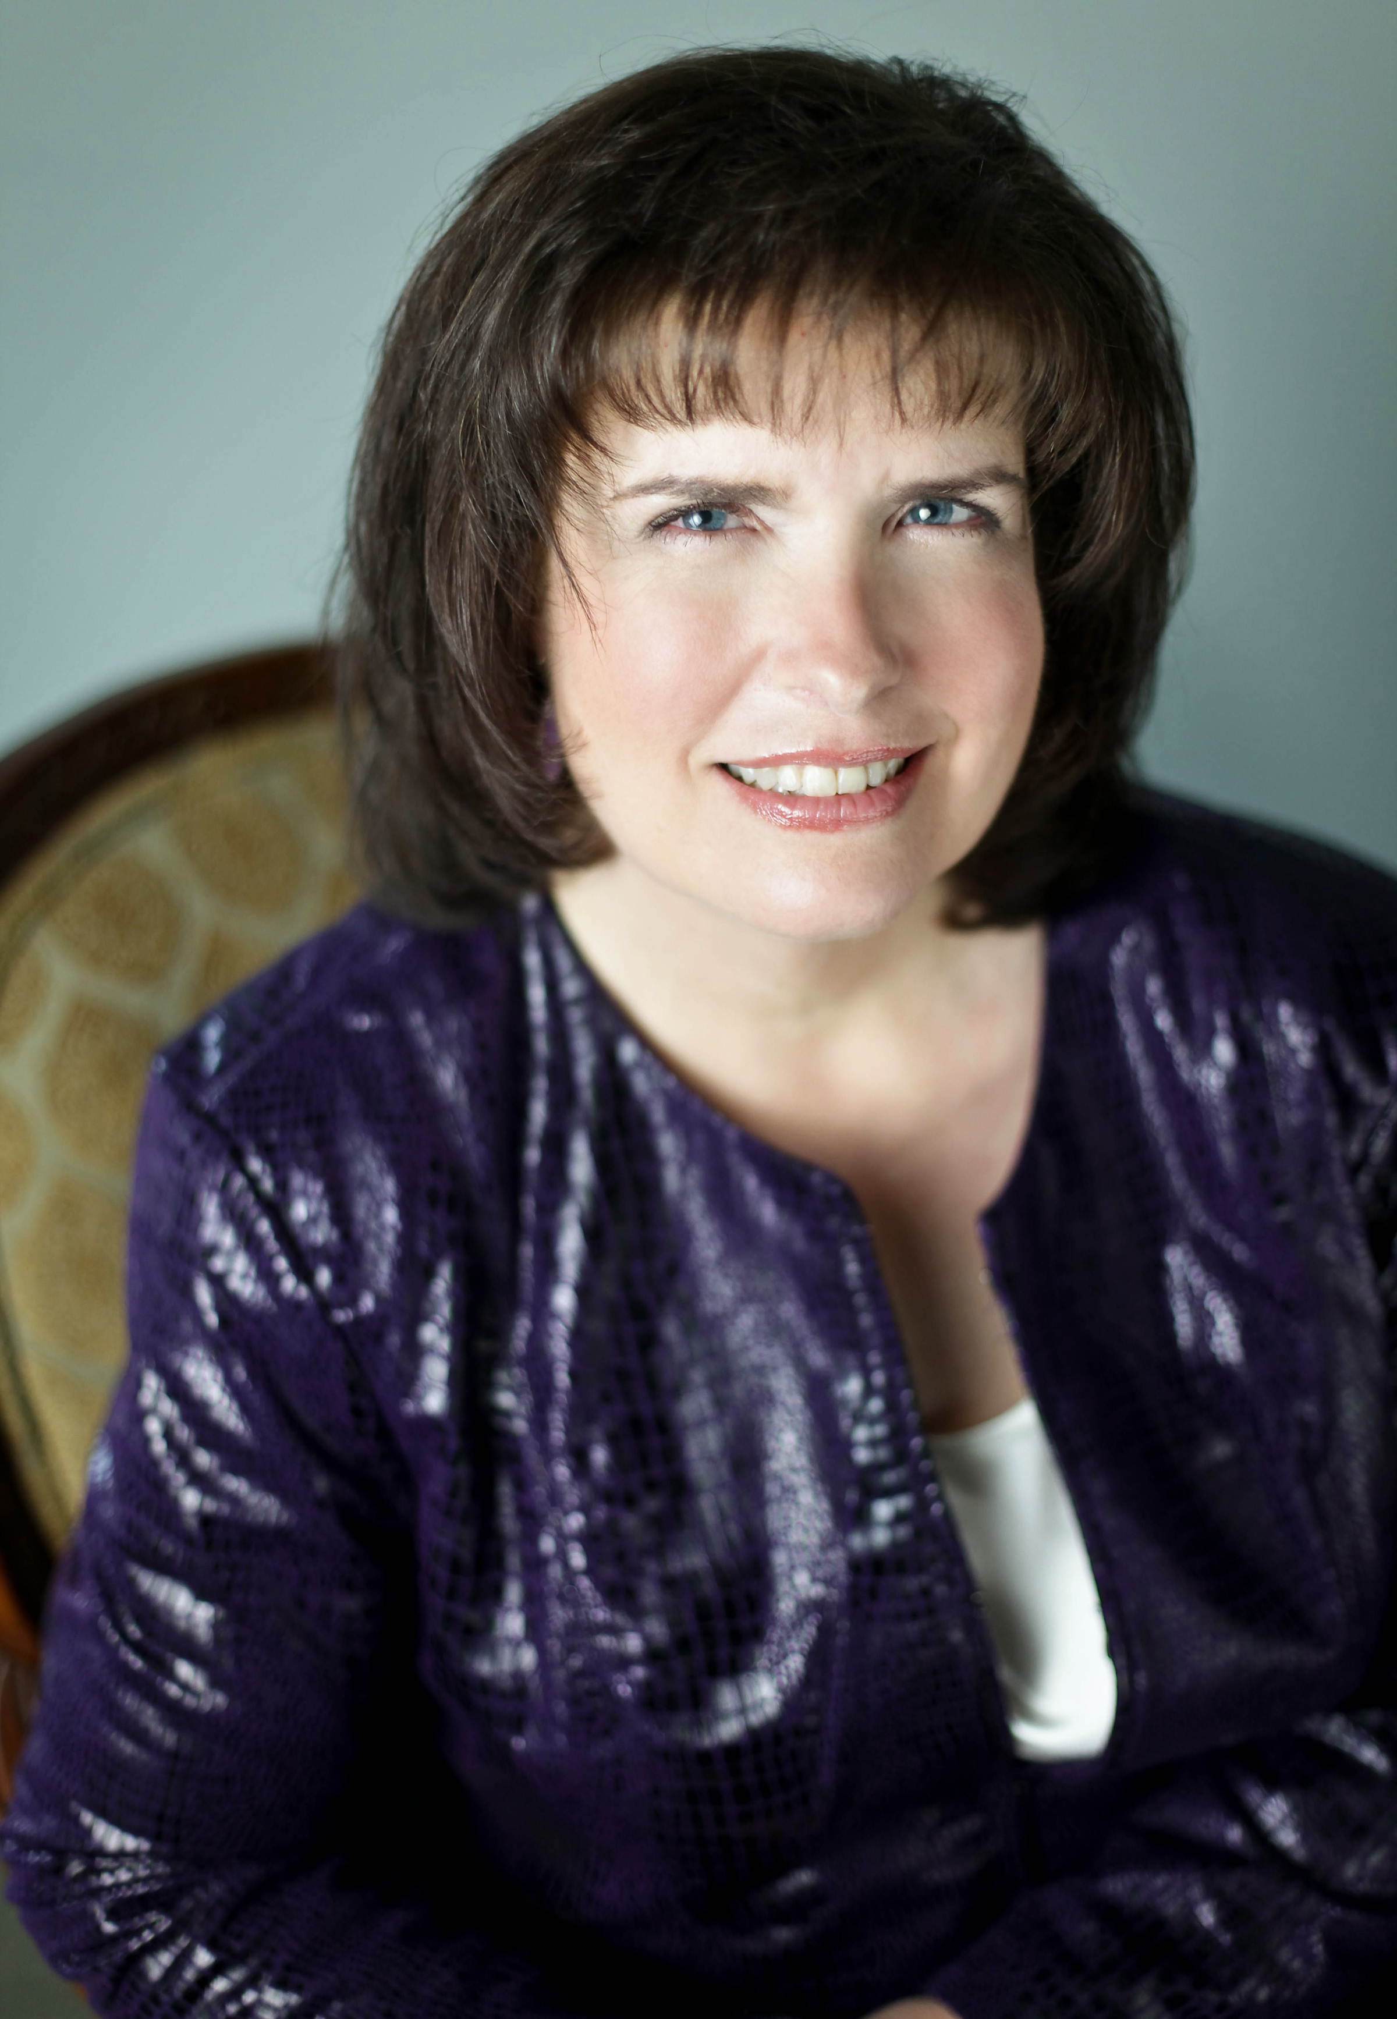Photo Credit Jessica Blakely for Tamara Lackey Photography
Raised amidst the rubber plantations in Thailand by missionary parents, Sabrina Jeffries has earned numerous placements on the New York Times and USA Today lists with Regency historicals that readers savor for her trademark sexy blend of witty dialogue and enterprising characters. It’s no accident she has been dubbed “The Queen of the Sexy Regency Romance.”
About that plantation business—living in the boonies of Thailand afforded Sabrina endless hours to read Jane Austen novels and other classics voraciously. Not surprisingly, back in the States, she went on to earn a doctorate in English literature from Tulane University—and a craving for Cajun food.
While Sabrina is at ease with refined academia types, she enjoys using her literary skills to pen novels of romantic fiction. She sold her first book in 1991 and has 39 published novels to her credit with more than eight million copies of her books sold worldwide. Whenever she struggles with a plot point, she shuts off the computer and tackles a jigsaw puzzle, and before long, bingo! Problem solved. Another stress-reliever for the inventive author: creating her popular Will and Jane’s Excellent Adventure comics. Displaying Sabrina’s fine-tuned sense of humor, the comics feature a William Shakespeare caricature figure and a Jane Austen action figure.
Caffeine addict, Third Culture Kid, chocoholic, and popular novelist with more than six million books in print, Jeffries defies labels. Her biting humor and simultaneous warmth endear her to her 30,000+ Facebook fans and Twitter and Pinterest followers. At home in front of a crowd—any crowd (no really, just hand over the microphone and get ready for some fun)—Jeffries is a sought-after speaker, as evidenced by her 2010 gig as emcee for the National Romance Writers of America’s 30th Anniversary Awards Ceremony.
While Sabrina treks through remote locales in the name of research and rubs elbows in the big cities with other industry professionals, she says her favorite destination is home. She lives in Cary, North Carolina, with her two best guys—husband, Rene, and adult son, Nick, who has inspired her to actively champion the cause of autistic children.

