New York Times & USA Today Bestselling Author
Sabrina Jeffries

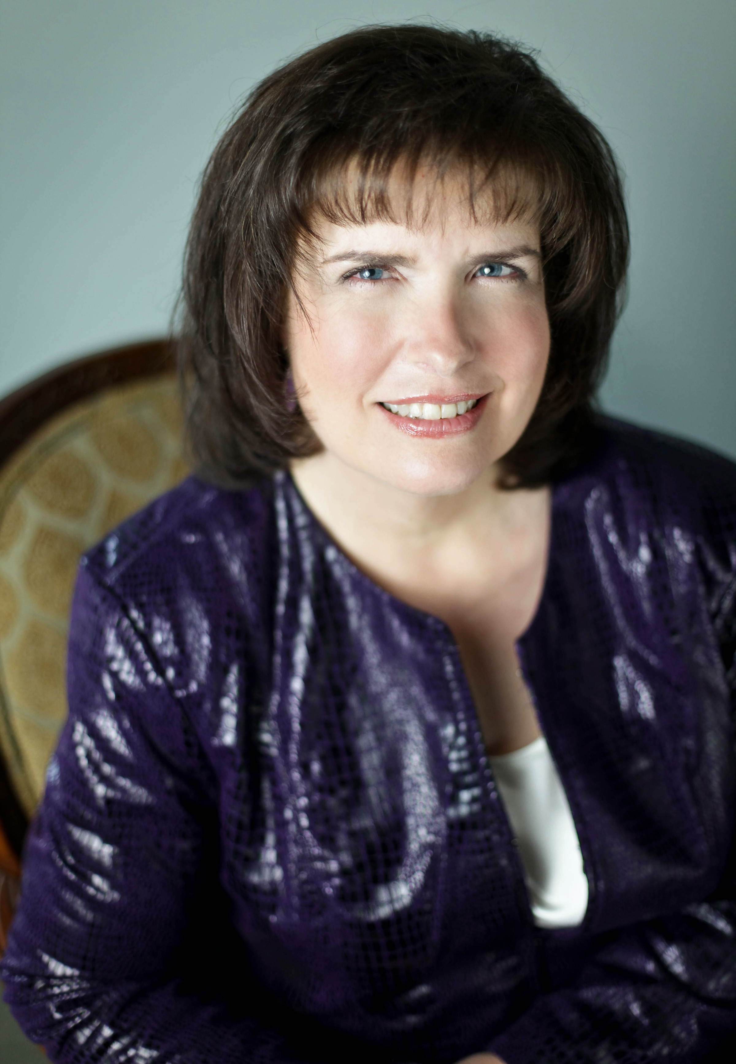
Photo Credit Jessica Blakely for Tamara Lackey Photography

Sabrina Jeffries (The Study of Seduction) is the New York Times bestselling and award-winning author of more than 50 novels and pieces of short fiction. With over 9 million books in print, the North Carolina author never regrets leaving her budding career in academics for the joy of writing fun fiction.

